**OUTPUT**

fetchrecord.php:

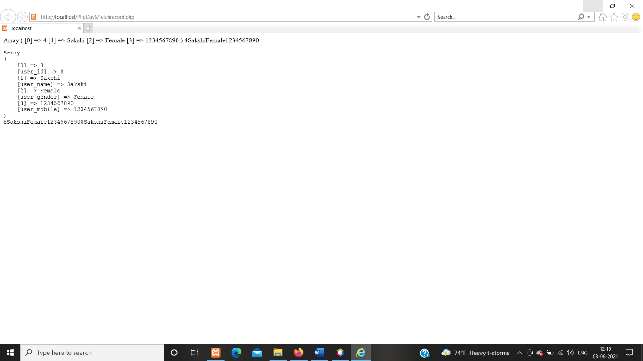

Display and delete Record in database:

